**Electrostatic Forces Notes**

* + Unlike charges will be _________________ each other.
  + Like charges will be _____________ from each other.
  + Neutral objects do not push each other away, but they are __________ to any charged object

Draw the arrows for the following diagrams.

The objects attract/repel because they are the same/different charge

The objects attract/repel because they are the same/different charge



The objects _______ because they are ________ charges

The objects _______ because they are the ________ charge

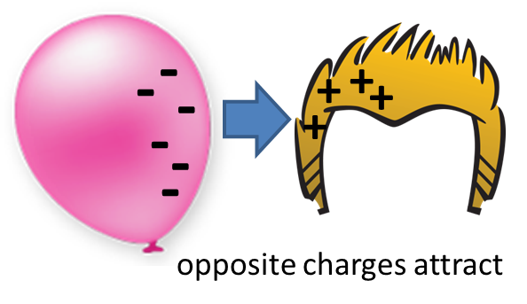

The objects _______ because they are ________ charges